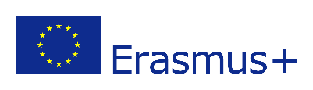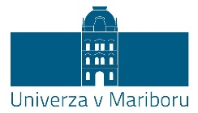

STAFF MOBILITY FOR TRAINING KA107 - 2017

APPLICATION FORM

INFORMATION ABOUT THE PARTICIPANT

Last name
First name
Nationality
Date of birth
E-mail
Passport number
Home address
Bank name*
Bank address
Clearing/BIC/SWIFT number*
Account/IBAN number*

* Bank account holder- participant

INFORMATION ABOUT THE MOBILITY

Planned period of the training activity
FROM (dd/mm/yyyy) |  | TILL (dd/mm/yyyy)
Duration (days) – excluding travel days
No. of additional days for travel

I, the undersigned
request from University of Maribor a grant for my mobility.

I declare:

that I am employed at the University of Maribor or at the partner institution from the partner country participating in Erasmus+ programme

that I fulfil the condition of CALL FOR APPLICATIONS FOR THE CO-FINANCING OF STAFF MOBILITY FOR THE PURPOSE OF TRAINING IN THE FRAMEWORK OF THE ERASMUS+ MOBILITY PROGRAMME BETWEEN PROGRAMME AND PARTNER COUNTRIES (KA107) FOR THE ACADEMIC YEAR 2017/18 (http://www.um.si/mednarodno-sodelovanje/erasmusplus/Strani/KA107-STT.aspx)

that all information contained in this application are correct to the best of my knowledge

Signature Place and Date:............................................

..................................................

A printed original of the application shall be addressed to the address below:

Univerza v Mariboru
International Relations Office
Slomškov trg 15
2000 Maribor
Slovenija

The application has to contain following attachments:
- Originally filled mobility programme in the »Mobility Agreement«, signed by the applicant and confirmed by the home and host institutions (Annex 2). It has to reflect the purpose and argumentation for mobility (goals, added value), the content of pedagogical work and the expected results.

